**Smart UI Form**

by Vectrum Technologies

"Smart UI Form" is an Unity asset, which can help you to create, or customize existing forms. In this document you will see how the things are going in the forms.

**How to setup**

After asset installation has been finished you can create your form (it can be either modified or not) this way: "Form" -> "Create Form" -> *preferred form.* You can add custom or default fields from "Form" menu to your form whenever you want.

**Field Type (Script)**

"Field Type" script is required for all gameobjects inside form. It identifies the type of every field. "Enable Custom Design" and "Enable Custom Alignment" values can be changed. By activating this allows you to change current component's design or alignment manually. All the other values must remain the way they are.

*"Field Type" gameobject*

**Form Controller (gameobject / script)**

This one is probably the most important component of the asset, where all things happen. You can change every component's design (colors, fonts etc.) or even set necessary positioning (horizontal, vertical, padding) and alignment from this script.

*"Form Controller" gameobject*

Form controller is the main component, where all the things happen. Let's see what can be done.

**Form Holder**

Form holder contains all the components except form background. It also has scrolling area attached on it, so you can resize it with "Form Holder".

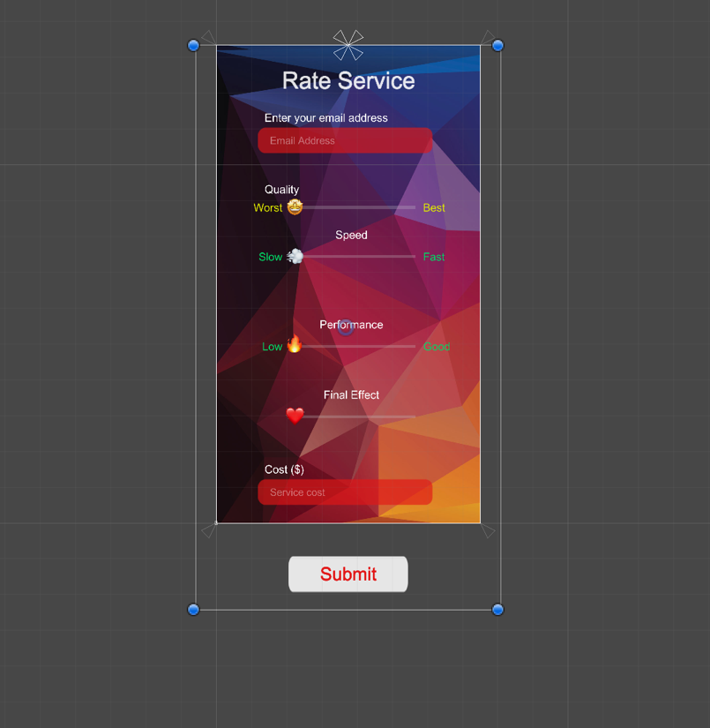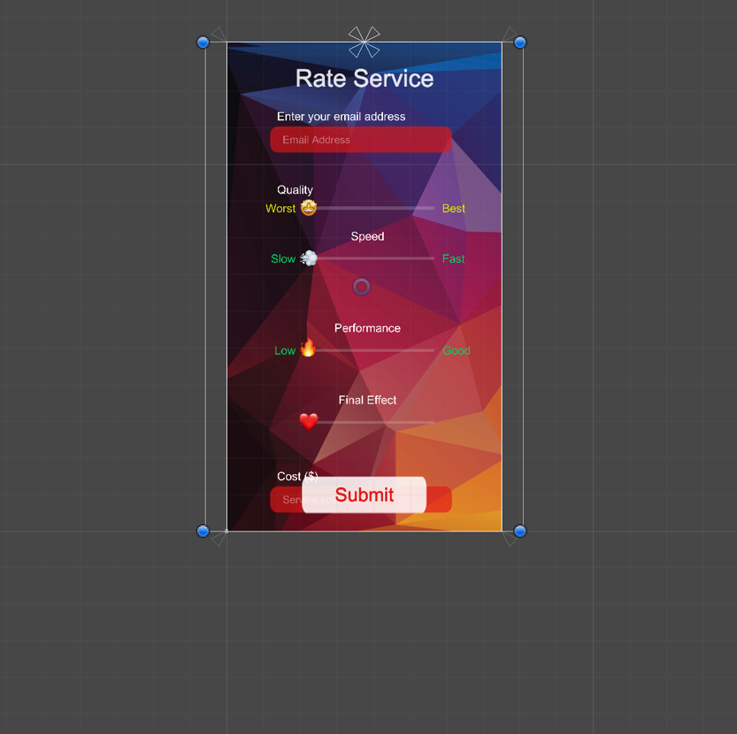

**Target Frame Rate**

*Resizing form's "Scroll area"*

Indicates that the game should render at the platform's default frame rate. Typically on mobile platforms the default frame rate is 30 frames per second. For better performance you can increase frames count.



*"Target Frame Rate" change area*

**Labels**

Every field has its own label. All the labels are being controlled by Form Controller. You can change their fonts, colors, font size etc.

*"Labels" change area*

**Title**

Every form has default title, which can be modified from this part of Form Controller. You can play with it however you want, change color, text, hide or show title background etc.

*"Title" change area*

**Fields**

Smart UI Forms are also very flexible, so you can change fields padding, vertical and horizontal positioning. Fonts and font styles can also be changed from here (except custom text field). All the changes are will affect fields, with "enable custom design" mode off.

*"Fields" change area*

**Background**

Every smart UI form has its own background. There are three types of backgrounds

* Solid color
* Dynamic
* Image

You can change background color, hide it or make its color change dynamically: just set preferred colors in public "Change Colors" array. You are able to set any picture as a background from "Form Controller" -> "Background" -> "Background Image".

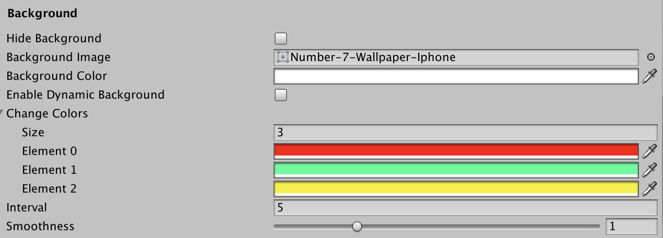

*"Background" change area*

**Submit Button**

Submit button is another required component for all forms. It is rather easy to handle with it, changing colors, fonts etc.

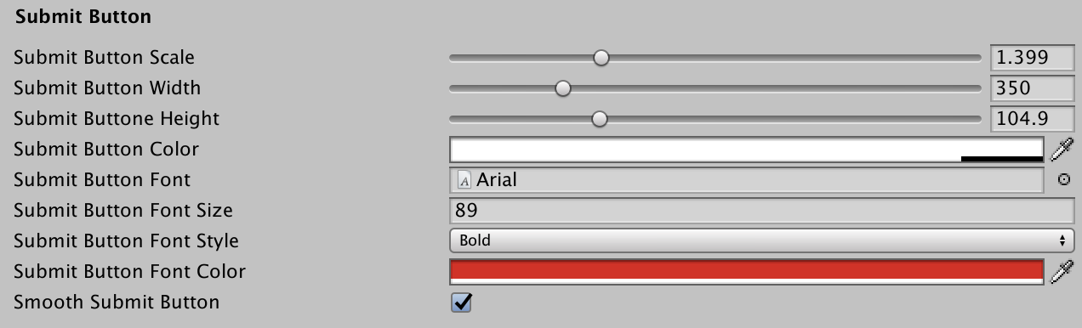

*"Submit Button" change area*

**After submit actions**

There are 3 types of this actions

* Change Scene After Submit
* Hide Form After Submit
* Show Back To Form

You can choose necessary action from popup. You will be able to write necessary scene name, if you want "Change Scene After Submit" action to take on. You can also set action delay time.

*"After Submit Actions" change area*

You can also get all the submitted data in your email, activating "Send Submitted Data To your Email". You need to complete some actions to get this option working.

1. Go into "File" -> "Build settings", choose "Android" platform and then open "Player Settings". Set "Internet access" option from "Auto" to "Require".

1. Sign In into your E-mail, where you want to get your data and activate "Allow less secure apps"(<https://myaccount.google.com/lesssecureapps>) to allow your app send messages into your e-mail.

1. Go back into unity and make sure you've entered your "E-mail" address and "Password", which is required for sending email.

**Note:** All the personal info is private and no one can access them.

Now all the submitted data will be sent to your e-mail address.

**How to add default or custom fields**

You can add some fields to your form like this "Form" -> "Add Field" or "Add Custom Field"

*Add default or custom fields*

**Input Fields**

Input Fields are very usable type of fields. A lot of forms at least have one input field. You can modify input fields from here

*"Input Fields" change area*

**Checkbox and Radio Button Fields**

These fields are rather similar functionally. They have 3 options as default. You can increase options by copy pasting some of options. This fields can be modified from here

*"Checkbox" and "Radio Button" fields change area*

**Dropdown Fields**

Dropdown fields have 3 options as default. You can increase options by copy pasting some of options. This fields can be modified from here

*"Dropdown" fields change area*

**Slider Fields**

These fields can be used as ratings or value setters. All the attributes can be changed from here

*"Slider" fields change area*

**Rating Fields**

Rating fields can be very useful, if you want to get some rating from your users. It has stars or circles as shapes, and can be modified from here

*"Rating" fields change area*

**Toggle Fields**

Toggle fields have two possible values ("Positive" - "Negative", "One Player" - "Two Players" etc.). These fields can be modified from here

*"Toggle" fields change area*

**Custom Text Fields**

Custom text fields are custom text choice in need. You can add "Forgot your password?" or "Give us your rating" etc. variants using this fields. They can be modified from here

*"Custom Text" fields change area*